Assignment 2 _B

Title:

|  |
| --- |
| Write a program to implement Parallel Bubble Sort and Merge sort using OpenMP. Use existing algorithms and measure the performance of sequential and parallel algorithms. |

**Outcome:** At the end of this session student will be able to:

1) Understand OMP thread model.

2) Parallelisation of for loop using OMP pragma instruction.

3) Able to write the code using OMP and paste it for result.

Theory:

Merge Sort Algorithm

Merge sort is the sorting technique that follows the divide and conquer approach.  It divides the given list into two equal halves, calls itself for the two halves and then merges the two sorted halves. We have to define the **merge()** function to perform the merging. The sub-lists are divided again and again into halves until the list cannot be divided further. Then we combine the pair of one element lists into two-element lists, sorting them in the process. The sorted two-element pairs is merged into the four-element lists, and so on until we get the sorted list.

1. MERGE_SORT(arr, beg, end)
3. **if** beg < end
4. set mid = (beg + end)/2
5. MERGE_SORT(arr, beg, mid)
6. MERGE_SORT(arr, mid + 1, end)
7. MERGE (arr, beg, mid, end)
8. end of **if**
10. END MERGE_SORT

Conceptually, a merge sort works as follows:

1. Divide the unsorted list into *n* sub lists, each containing one element (a list of one element is considered sorted).
2. Repeatedly [merge](https://en.wikipedia.org/wiki/Merge_algorithm) sub lists to produce new sorted sub lists until there is only one sub list remaining. This will be the sorted list.

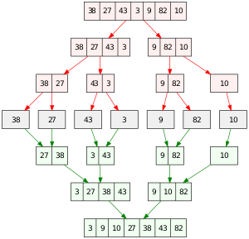

Scaling up merge sort on 8 processor

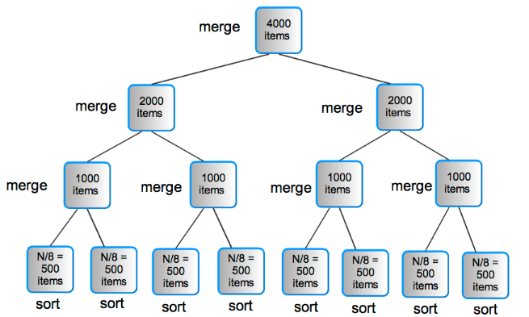

The time complexity of Merge Sort is θ(N log(N))

**Auxiliary Space:** O(n), In merge sort all elements are copied into an auxiliary array.

OMP programming model:

OMP is an application programming interface that supports shared memory multiprocessing programming in C, C++ and other platform. OMP uses portable simple& flexible interface for developing parallel application for platform ranging from desktop computer to super computer.

Thread Modes:

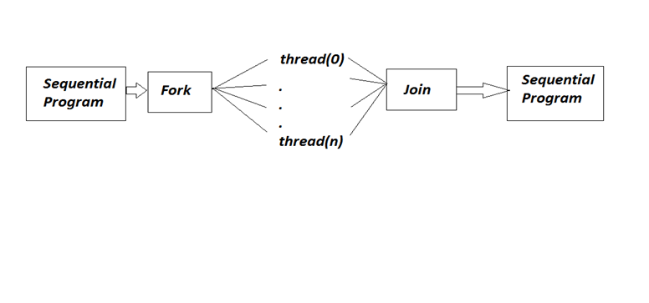

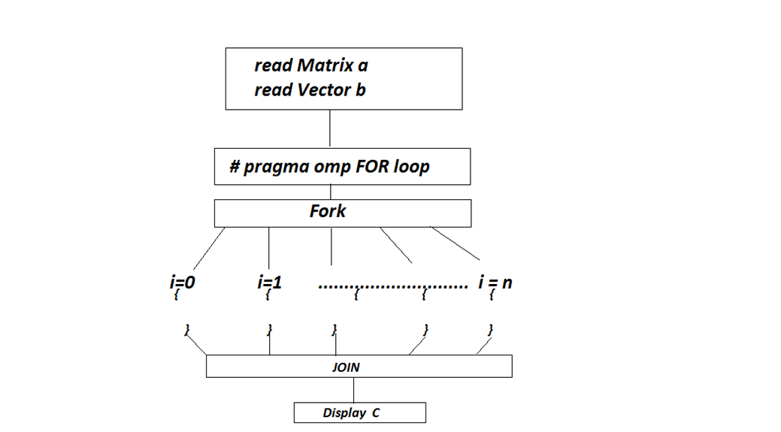

Procedure:

1) Developed & install CodeBlock/Colab compiler which has inbuilt OMP library.

2) Write a program in Text editor & save it as .c extension.

3) In OMP header file used is<omp.h>

4) Built & run program.

5) Verify the result.

**Conclusion:**

Parallel operation of merge sort is implemented using OMP compiler. Performance of sequential and parallel model is compared.